Army Reserve Enterprise Building Control System (EBCS)
Design Guide

July 2020

Table of Contents
List of Acronyms 1
1.0 Introduction 3
1.1. EBCS System Architecture 3
2.0 Technical Design Guide 4
2.1 Hardware 4
2.2 Steps for Integration 4
2.2.1 Installing JACE 4
2.2.2 JACE Setup and Configuration 5
2.2.3 JACE Programming 5
2.2.4 Graphical User Interface (GUI) 6
2.2.5 Final Steps 7
Attachment A. Unified Facilities Guide Specifications 8
Attachment B. Integration Ready Definition 8
Attachment C. Site Readiness Assessment 8
Attachment D. DHCP Reservation 8
Attachment E. JACE Enclosure Layout 9
Attachment F. User Profiles 9
Attachment G. Point Naming Convention 9
Attachment H. QA/QC Checklist 9

List of Acronyms
ARNET: Army Reserve Network.
BCS: Building Control System
DHCP: Dynamic Host Configuration Protocol
EBCS: Enterprise Building Control System
FAC: Facility
FACNUM: Facility Number
FOXS: Secured communications protocol developed as part of the Tridium Niagara framework
GUI: Graphical User Interface
HTTPS: Hypertext Transfer Protocol Secure
HVAC: Heating, Ventilation, and Air Conditioning
IC: Integration Controller
IP: Internet Protocol
JACE: Java Application Control Engine
JAR: Niagara software operations modules
MAC: Media Access Control
NAC: Network Area Controller
NEMA: National Electrical Manufactures Association
POC: Point of Contact
QA/QC: Quality Assurance / Quality Check
QNX: Operation system
RD: Readiness Division
RD EBCS POC: Readiness Division Enterprise Building Control System Point of Contact
SRA: Site Readiness Assessment
TCP: Transmission Control Protocol
TLS: Transport Layer Security
UFGS: Unified Facilities Guide Specifications
UL: Underwriters Laboratories
WIFI: Wireless network

Introduction
The Enterprise Building Control System (EBCS) Technical Design Guide provides the technical details for both EBCS equipment and hardware; and the system configuration. This guide follows and is supplemental to the standards of UFGS 23.09.00 and UFGS 25.10.10 found in Attachment A.

EBCS System Architecture
The EBCS architecture relies on the Tridium Niagara 4 Framework to provide seamless integration of common and accepted hardware at the building level to communicate with a central server at the “enterprise” level. The Java Application Control Engine (JACE) is the device that provides a firewall to allow local building controls from various vendors to connect to and communicate across the ARNET (see Figure 1).
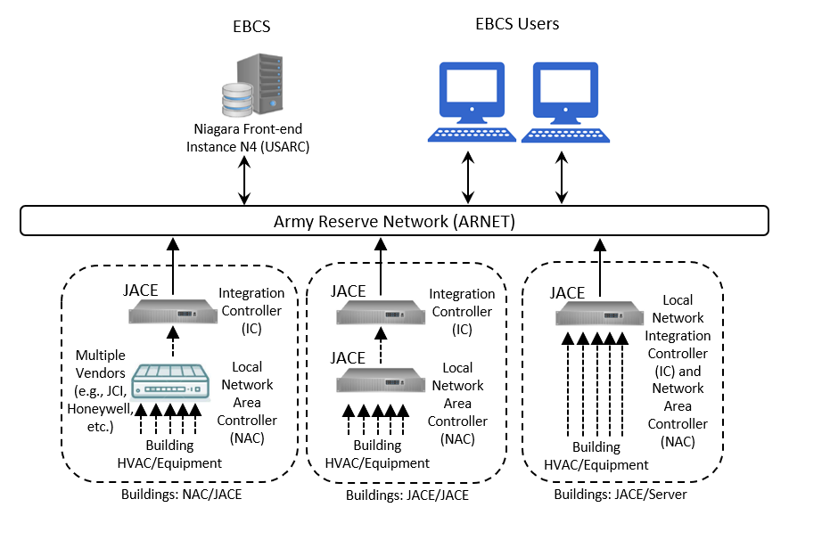
Figure 1. EBCS Simplified Architecture
The NAC/JACE example in Figure 1 shows building equipment (e.g., chillers, air-handlers, etc.) connected to a proprietary vender’s device called a Network Area Controller (NAC). The NAC cannot be connected to the ARNET directly. Therefore, an Integration Controller (IC) JACE serves as a gateway to make the data and control function of the local BCS/NAC available across the network. Sometimes the NAC is also a JACE but dedicated to building-level functions only, thus resulting in a JACE/JACE configuration. Lastly, the JACE/Server configuration uses a single JACE as both the NAC and IC, although users should be careful that these functions do not over-whelm the capabilities of the JACE. This configuration will be determined by the RD with support from the integration contractor. In a retrofit of an existing building control system, any of the above EBCS architecture could apply and requires an SRA with a proposed changes and upgrades needed to make the building integration ready. If the building is going through full retrofit or is new construction, the architecture that will be used in the BCS is the JACE to Server configuration.

Technical Design Guide
This guidance provides a framework for systems that are NAC/JACE, JACE/JACE, and JACE/Server configurations. Integration configuration shall be determined by each Readiness Division (RD). The determination of these configurations relies not only on technical capabilities, but also contractual parameters. Hardware and system responsibilities must be taken into consideration while evaluating the integration configurations.
This step is for all existing control system retrofit and will require that all the steps listed below be completed in order to insure a BCS is adhering to all EBCS standards. A BCS is considered “Integration Ready” when the system does not require any additional work before establishing a connection and integrating to the EBCS server. Review Attachment B to determine when the system is integration ready. The primary integration steps are determining the integration configuration and verifying the JACE, establishing communications between the JACE and the EBCS server, and establishing links to all the points in the existing system.
For new construction and full building retrofit, the following steps are not applicable for making a BCS “Integration Ready”: Step 2.2, Step 2.2.5.b.ii

Hardware
The IC JACE must meet the following specifications regardless of the integration configuration.
- JACE 8200 with an open license, for example VYKON. License version must be 4.3.58 or newer with the Wi-Fi disabled.
- License must include the workbench tools to be installed on the JACE.
- A dedicated UL-listed, Class 2, 24Vac power supply with a manufacture approved surge protection. The JACE must be powered by a dedicated breaker or off the circuit providing power to the local BCS NAC (if existing).
- Mounted in a NEMA Type III enclosure with associated wiring, fusing, and mounting blocks.

2.2 Steps for Integration
- Prior to integration, a Site Readiness Assessment (SRA) must be performed on all facilities appropriate for integration at that site. At a minimum the RD EBCS POC will provide guidance to the contractor on which facilities require a SRA. The SRA can be found in Attachment C.

Installing JACE
- The JACE MAC address, serial number, QNX code, and additional information must be entered in the “Request for DHCP Reservation Form” in Attachment D and submitted to the RD EBCS POC and ARIMD EBCS Sustainability Manager for DHCP reservation.
- Integration contractor shall work with the RD POC to determine the ideal location of the JACE. The ideal location for the JACE is in an IT closest or in a Mechanical room that houses most of the equipment for the building.
- Connect the JACE to the local BCS NAC (if existing) and provide all Cat 6E cabling to the ARNET switch.
- Any onsite BCS computers inside the building used for control or monitoring need to be connected on the Port 2 side of the JACE and remain operational.
- Label JACE with station name and Port 1 and Port 2 MAC address
- Review Attachment E for a JACE enclosure layout for further technical installation guidance.

JACE Setup and Configuration
- A Cat 6E cable must be plugged into Comm 1 of the JACE from the ARNET switch.
- Only the following runtime profiles shall be enabled.
  - RUNTIME: Module JARs having core runtime Java classes only, no user interface.
  - UX: Module JARs having lightweight HTML5+JavaScript+CSS user interface only.
  - WB: Module JARs having Workbench or Workbench Applet user interface classes.
- A standardized station name and hostname that will be provided by the RD POC. Station name and hostname will adhere to the following format.
  - HVAC Controls Station Name: FACID_FACNUM_C01
  - MDMS Station Name: FACID_FACNUM_M01
- A station template will be provided by the RD EBCS POC that must be used by the contractor.
- All communications between Niagara devices and the EBCS server will be secured with SSL, using the following points.
Interface | Protocol | Specified Port
Internet Browser | HTTPS | 443
Niagara Station | FOXS | 4911
Niagara Station | TLSv1 | 5011

- When configuring the JACE in the TCP/IP configuration screen, Comm 1 will be set for DHCPv4 enabled. DHCPv6 will be disabled. Configure Hostname to match station name.
  - HVAC Controls Hostname: FACID-FACNUM-C01
  - MDMS Hostname: FACID-FACNUM-M01
- When configuring the Jace in the TCP/IP config screen, Comm 2 on the JACE will be configured with a standardized static IP address and subnet mask to allow for a local laptop to be connected for future onsite work.
- Refer to the document titled “User Profiles” (Attachment F) for configuration of username and password combinations and system passphrases.

JACE Programming
- A standardized point naming convention will be used in the JACE for all data points as listed in “Point Naming Convention in Attachment G.
- Alarm extensions will be added to the data points as designated in the “Point Naming Convention”. Alarm messages will be added to each alarm as outlined below.
  - Out of Range (Analog Points). The message will display the current value of the point and either the high or low threshold.
  - Command Failure (Boolean Point). The message will display the current command of the point and the current status.
  - Change of Value (Boolean or Enumerated Points). The message will display the current value of the point.
  - Change of Status (Niagara Components). The message will display the current value of the component.
- Trend extensions will be added to the data points as designated in the “Point Naming Convention Guide”. The data types that will be used for the trend extension are outlined below.
  - Interval Trends. This trend type will be assigned to analog points that are fast changing in nature. The trend extension will be configured to record a data point every 5-15 minutes.
  - Change-of-Value Trends. This trend type will be assigned to either analog or Boolean points that are not fast changing in nature. The trend extension will automatically be configured to record a data point whenever there is a change of value in the point.
- The trend extension configuration will be set to allow for a minimum three-day rolling window of data, but not to exceed 1800 records per JACE.

Graphical User Interface (GUI)
- A station template will be provided by the RD EBCS POC that contains the GUI package that must be used by the contractor.
- The GUI package will provide template graphics for system and equipment level screens, layout, and functionality.
- The contractor will edit the equipment level screens to be representative of the equipment configuration and piping/ducting layout.
- Floorplans will be provided by the RD EBCS POC will be added to the floorplan graphics by the contractor.
  - The contractor will implement a floorplan color presentation to match each zone as served by the HVAC system. The floorplans in the template station can be used as an example.
  - The contractor will implement a zone temperature deviation calculation for each zone and integrate the deviation into the floorplans. The deviation scale will be setup as followed. The floorplans in the template station can be used as an example.
Green: when zone is +/- 2°F of setpoint
Yellow: when zone is above setpoint by 2-4°F
Orange: when zone is above setpoint by 4-6°F
Red: when zone is above setpoint by more than 6°F
Light blue: when zone is below setpoint by 2-4°F
Blue: when zone is below setpoint by 4-6°F
Dark blue: when zone is below setpoint by more than 6°F
- Contractor shall install all building graphics on the IC JACE. If the JACE was login into at the building the graphics from the building down to the equipment should look the same as the server level graphics.

Final Steps
- The contractor will work with the RD EBCS POC to test and verify the access and basic functionality of the new JACE is satisfactory while accessing the system remotely.
- The contractor will provide the following to verify quality workmanship.
  - Use hole-knockout protectors, properly aligned holes, and do not leave any jagged edges.
  - Submit photos of before and after JACE installation including close up images of the cable connections at the JACE and at the local BCS (if existing), cable pathways, and all enclosure penetrations.
  - Completed QA/QC checklist found in Attachment H.
  - Red-lines of building layouts and equipment manuals/documentation in Microsoft Office format.

This table lists the attachments that need to be completed or followed for each of the different retrofit/construction tasks
Attachments | BCS Retrofit | New Construction/ Whole Building Retrofit
A | X | X
B | X
C | X
D | X | X
E | X | X
F | X | X
G | X | X
H | X | X

Attachment A. Unified Facilities Guide Specifications
The EBCS framework and all underlaying BCS must be in accordance to the Unified Facilities Guide Specification (UFGS) from the Department of Defense. Below are the links for the full versions of the applicable specification. Amended examples are in Attachment A.

UFGS 23 09 00: Instrumentation and Control for HVAC
http://www.wbdg.org/ffc/dod/unified-facilities-guide-specifications-ufgs/ufgs-23-09-00

UFGS 25 10 10: Utility Monitoring and Control System (UMCS) Front End and Integration
http://www.wbdg.org/ffc/dod/unified-facilities-guide-specifications-ufgs/ufgs-25-10-10

Attachment B. Integration Ready Definition
Attachment B provides the definition of systems that are considered “Integration Ready”. A BCS is considered Integration Ready if it meets all the critical criteria without needing additional work.

Attachment C. Site Readiness Assessment
Attachment C is the SRA workbook that must be completed before any system is integrated to the EBCS. This excludes full building retrofits and/or new construction. The primary functions of the SRA are to:
- Gather details about the current BCS (vendor, software, IP, etc)
- Perform functional testing on the BCS in relation to the integrated mechanical equipment
- Determine if the BCS is Integration Ready
- Complete an onsite checklist on BCS, HVAC, networking, and metering details
- Draft preliminary list of expected costs

Attachment D. DHCP Reservation
Attachment D is the form that can be used for submitting DHCP and IP reservations and assist RD’s with technical documentation. The form includes the following fields:

- FAC ID and Building
- Panel Name
- Tridium Jace Model
- MAC Address Port 1 & 2
- Serial Number
- QNX Code
- Station Passphrase
- Host ID#
- Platform Username & Password
- DHCP Reservation
- Port 1 & 2 DHCP IP Address
- Port 1 & 2 DHCP Subnet Mask

Attachment E. JACE Enclosure Layout
Attachment E provides schematics for potential parts list and JACE wiring diagrams.

Attachment F. User Profiles
Attachment F is the user profile sheet detailing the specifications for credentials, roles, and accessibility for each user. These will be defined by each RD and will be specific to the needs of each RD.

Attachment G. Point Naming Convention
Attachment G provides the naming conventions for control points. Additionally, this table indicates which points should be trending (storing data histories) and which should be generating alarms on faults.

Attachment H. QA/QC Checklist
Attachment H is the QA/QC checklist to be completed after EBCS integration is complete.

